<https://www.digitalocean.com/community/tutorials/react-server-side-rendering>

npm install -g win-node-env

上述为了解决：

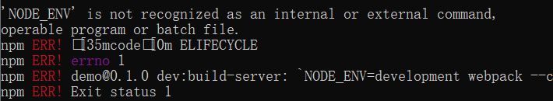

<https://stackoverflow.com/questions/11928013/node-env-is-not-recognized-as-an-internal-or-external-command-operable-comman>

<https://www.pluralsight.com/guides/how-to-partly-server-side-render-in-react>